Branch of the autonomous educational organization
"Nazarbayev Intellectual School"
Nazarbayev Intellectual School of Natural Sciences and Mathematics in Uralsk

Mankeyev Ayan, 10th Grade
Alshinov Akniet, 10th Grade

«KepTESS»: AI EXoplanet SATELLITE & analysis pipeline

Category: Applied Science

Mentor:
Bisekenov Medet, salaladlas

Astana, 2026
Оглавление
Abstract 3
1. Introduction 4
2. Research section 4
2.1 Analytical review of known results 4
2.2 Description of the methods for solving tasks 5
2.3 Pipeline creation 6
2.4 Relay satellite creation 6
2.5 Results and Discussion 6
3. Conclusion 7
Key Results of the Work: 7
Conclusions and Recommendations for Using the Results: 7
4. References 8

Abstract
The rapid growth of astronomical data from space missions such as Kepler and TESS has created new opportunities for exoplanet research, while simultaneously increasing the gap between data availability and accessible analysis tools for students and early researchers. This project presents KEPTESS, an end-to-end, transparent pipeline for detecting exoplanet candidates from photometric time-series data, combined with a conceptual relay satellite model.
The objective of the research is to design an interpretable and reproducible system for exoplanet transit detection using open astronomical data. The hypothesis is that classical signal-processing methods, when combined with clear visualization and simple AI-assisted classification, can provide reliable results without the complexity of large proprietary pipelines.
The research methodology includes preprocessing and detrending of stellar light curves, transit detection using the Box Least Squares algorithm, statistical and visual validation of candidates, and graphical interpretation of results. The pipeline was implemented in Python with an interactive web interface built using the Gradio framework. Additionally, a prototype relay satellite was developed to demonstrate a complete data acquisition and transmission concept.
The results show that the pipeline successfully identifies periodic transit-like signals in Kepler data while maintaining full transparency of the analysis process. The novelty of the project lies in integrating data stitching, visualization, algorithmic detection, and beginner-oriented design within a single modular system.
The developed solution is suitable for educational use, independent research, and preliminary exoplanet candidate screening.

1. Introduction
The Kepler Mission, NASA’s Discovery-class project, launched March 6 in 2009 and pioneered the hunt for planets orbiting in habitable zones of nearby stars that are similar to Sun. Kepler monitored light curves from thousands of distant targets, detecting planetary transits - small dips in stellar brightness when a planet crosses its star’s disk from our viewpoint. [1]
Similar missions and Kepler caused fast growth of large amounts of astronomical data. Despite the data being widely available, access to understandable analysis tools for students, new researchers, and citizen scientists stays limited. Professional pipelines are mostly for big processing and function as closed systems. Because of that, they are not used for educational use or research, and the gap between data scale and the ability to analyze and understand it is widening.
Addressing this issue is particularly important in the context of increasing importance of STEM education, data literacy and reproducible science. Developing an accessible and scientifically accurate pipeline for exoplanet detection contributes to solving these challenges and the bigger goal of making scientific research available to everyone.
By measuring repeated events with consistent period, duration, and depth, Kepler identified planets and got their orbital parameters. [1] KEPTESS strives to work with this transit method: after missions, such as Kepler and TESS, send the data to our relay satellite, the developed pipeline analyzes light curves and other parameters. The difference of the pipeline is that it aims to visualize astronomical data in clear graphics, be beginner-friendly and use simple AI candidate classification.
The primary objective of this work is to design and implement a transparent, end-to-end pipeline for detecting candidate exoplanets in photometric time series data from space missions.
The specific objectives are:
- To process and clean raw FITS(Flexible Image Transport System) photometric data using standard preprocessing and detrending techniques;
- To apply the BLS(Box Least Squares) algorithm for identifying periodic transit signals;
- To validate detected candidates using statistical and visual criteria;
- To provide clear visualizations to increase the interpretability of the results;
- To create a foundation for future extensions, including machine learning-based classification and educational applications.
Project’s methodological basis lies in the Design Thinking methodology, which consists of 5 stages:
1) Empathy - analyzing the problem of the audience based on own observations;
2) Research - reviewing scientific literature and methods in the field of astronomy to tackle tasks of the project;
3) Idea generation - generating ideas on how to implement the solution of the problem based on scientifically proven methods;
4) Prototyping - developing a prototype of the AI identification pipeline and relay satellite;
5) Testing - running tests of the pipeline and analyzing the results.
The scientific novice of the project is due to covering stitching quarter files together, clearly visualizing data in 3 different ways, having both understandable frontend and modular backend, using AI classification along with algorithmic interpretation and providing useful definitions of the terms all in one pipeline. This ensures maximizing user experience and educational value of the pipeline.

2. Research section

2.1. Review of known results
According to scientific literature, the detection of exoplanets using photometric transit methods is one of the most successful in modern astronomy. Space missions, such as Kepler and TESS , led to the discovery of thousands of confirmed exoplanets and candidates by monitoring periodic decreases in star brightness caused by planetary transits. Then professional analysis pipelines were developed to process the large volume of data from these missions. For example, the Kepler Science Processing pipeline and the Science Processing Operations Center pipeline.
The pipelines use detrending, transit search algorithms and many validation stages. For example, BLS - an algorithm for detecting periodic, box-shaped decreases in brightness similar to planetary transits - and TLS(Transit Least Squares) - more precise algorithm than BLS, - are often used. Despite being effective for large analysis, existing systems are for efficiency and not interpretability. Because of that, they often function as closed, thus limiting user interaction with analysis stages.
Several open-source tools, like Lightkurve, provide some access to mission data and allow users to perform custom analyses. However, these tools typically require advanced knowledge and do not offer full workflow with focus on education or research. Moreover, recent machine learning-based approaches, like convolutional neural networks (CNN) or, to put it simply, visual analysis by AI for candidate classification, demonstrate high performance, but reduce accessibility for beginners.
Overall, existing solutions demonstrate strong detection capabilities, but reveal a gap between professional and simple analysis tools. This gap revealed the need for open and flexible pipelines that support learning, experimentation, and independent validation of exoplanet candidates.

2.2 Pipeline creation

2.2.1. Methods of the pipeline
The tasks of this project were solved using a structured methodological approach based on astrophysical data analysis and time-series processing techniques. The main method involves the analysis of photometric light curves - containing the time on X-axis and the flux or brightness on Y-axis - obtained from space missions such as Kepler. The code was written in Python and frontend implemented with the Gradio package. It is an open-source framework, that allowed to build a functioning website for the pipeline. [3]
Firstly, data is extracted from Kepler-style FITS files with the help of “fits” Python library from the “astropy” package and the code automatically finds flux columns, such as PDCSAP_FLUX, SAP_FLUX, FLUX, by priority. It is prioritized because of PDCSAP_FLUX columns having additional long-term detrending, removal of outliers and is often more recommended for transit search, SAP_FLUX being simple aperture photometry without the PDCSAP correction thus being less clean, FLUX also not having the correction and being used as a universal a name for user-generated files thus is treated as a fallback. [4] The “numpy” library aids in making arrays in the “read_time_flux_from_hdu” function and then the next function tries to find the matching table from the files to match the TIME column with the FLUX column.

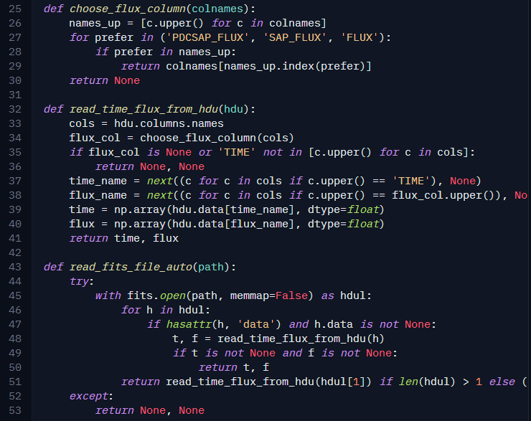
Photo 1. Extracting data

Secondly, raw photometrics go through preprocessing. This includes the removal of missing values and non-finite data, outlier rejection, and median-normalization of flux values for the stability of numbers. To suppress stellar variability and instrumental trends that can obscure transit signals, we used detrending methods based on smoothing filters.
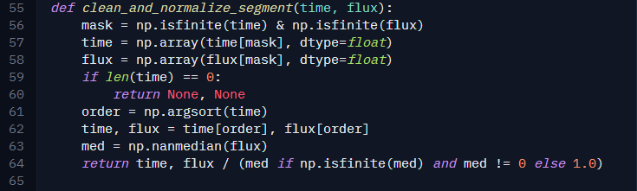
Photo 2. Preprocessing data

Thirdly, in case the user uploads not just one FITS file, then the code will stitch the files together. This helped us to allow analysis of multiple quarters up to 19. Code below covers assigning indexes to files, sorting and concatenating them and then smoothing the stitching by median-normalizing or Savitzky-Golay filter from the “scipy” python library. Overlaps in time are also masked.

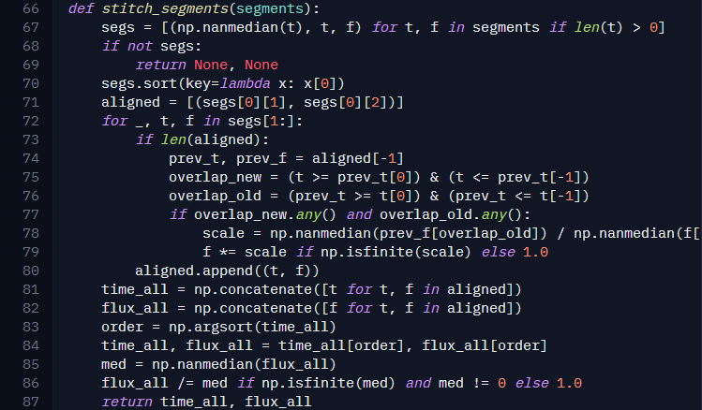
Photo 3. Stitching files together

Fourthly, the detection of potential exoplanet transits was performed using the BLS algorithm from the astropy package, which is designed to identify periodic, box-shaped dips in brightness characteristic of planetary transits, as mentioned in the 2.1 chapter. It was configured to scan a defined range of orbital periods and transit durations, allowing flexibility in the detection of both short- and long-period candidates. To validate detected signals, statistical indicators, such as signal detection efficiency(SDE) and transit depth, were calculated.
Lastly, the algorithms generated 3 plots: time-series light curve, BLS periodogram and phase-folded light curve. Time-series light curve contains brightness and time of all the stitched quarters, showing all the transits. Meanwhile BLS periodogram shows how strong a signal is and answers at what periods transits repeat. Lastly, phase-folded light curves help assess the consistency of the transit features. Visual inspection of these curves is used as a supplementary method to identify false positives caused by noise or stellar activity. The end-to-end pipeline methods ensure transparency and flexibility of the analysis. This way both independent research and educational use is maintained.

> Desc of modules, gradio
> Photo of the interface
> Desc of features of the pipeline
> Testing the pipeline and explaining how to identify an exoplanet with it

2.2.2. Pipeline User Interface and User Experience
As said earlier in the 2.2.1. ch., the user interface(UI) was coded using the Gradio package in Python. UI consists of multiple fields. Firstly, we have a file field, where user can upload one or even multiple FITS files for convenience of the analysis. Then, with the press of a button, the analysis starts.
Secondly, the BLS and AI output is generated in the text field along with 3 plots clearly visualized in the image field.

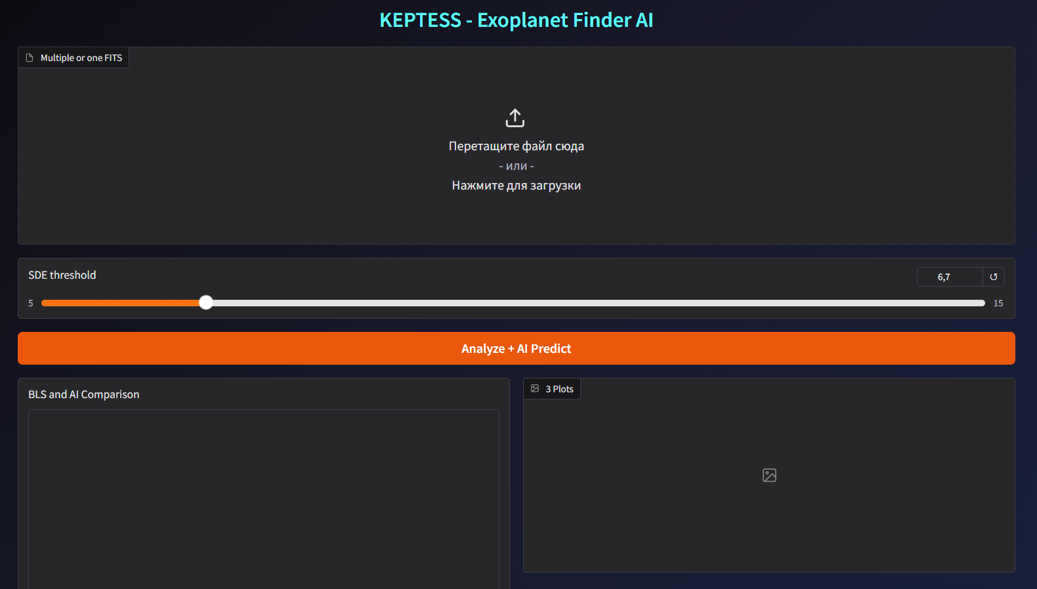
Photo 4. UI

Lastly, there is a “Help” section, that contains the definition of the terms for users to get familiarized with for understandable workflow. They can either use a dropdown or type in the term themselves.
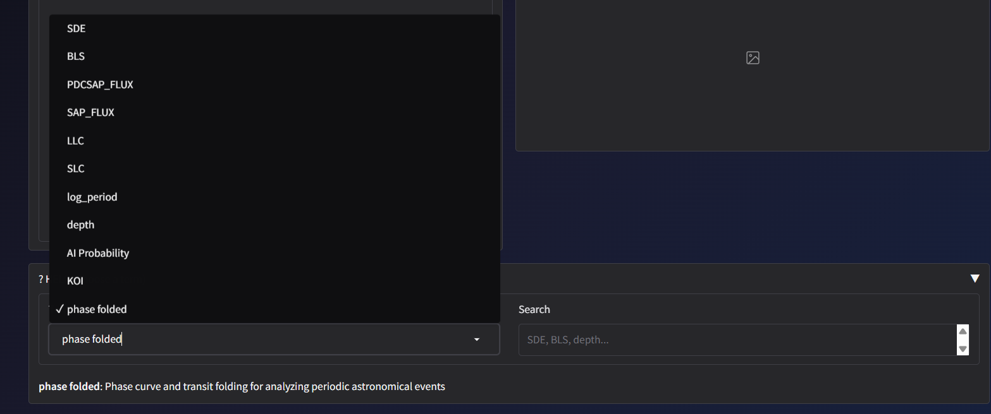
Photo 5. Dropdown

2.3. Relay Satellite Prototype Creation
A prototype of a relay satellite was made to demonstrate how the pipeline would work when paired with a satellite. It consists of two parts: the main body and the reflector. The main body is a hexagonal cylinder, inside of which there is a power unit, an Arduino UNO and a hole that allows the cable from the solar panel to be placed on one of the outer sides of the cylinder.
Arduino UNO is located between the body and the reflector, which reduces the risk of damage in case of a crash. It keeps the same function as the pipeline - data analysis. The reflector (or mirror) is the largest concave part that reflects and focuses radio waves. That is, the reflector gets the signals as data from the Kepler and TESS mission and transmits them to the main part, then the data is processed and we get a file with reworked data. This data is sent to stations on Earth. As mentioned earlier, the device gets energy from the solar panel, since it will be difficult to refuel at a great distance. And in its inner part is a power supply unit (in this case Powerbank). Moreover, solar energy is the most proven, affordable and safe form of energy. The prototype is made of accessible and easy materials for ease of assembly. The body is made of foamed polyvinyl chloride, and the reflector is made of golden plexiglass, because its golden paint has an advantage in space.

2.5 Pipeline testing
To check the performance of a pipeline, grab the files from the Kepler mission database [5]. To analyze a whole candidate, entire quarters are analyzed. Quarters are the pieces of data from a complete file, because missions scan the objects in parts and at different times, so files are split into pieces.
Fits files are uploaded to a special platform, where they are glued together, detrended and analyzed.
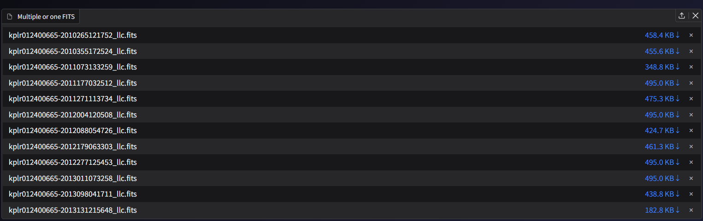
(Photo 6. Space for uploading )
After the analysis in the first cell is shown BLS and AI Comparison, to compare the indicators of the analysis of the BLS method and the analysis of the AI.

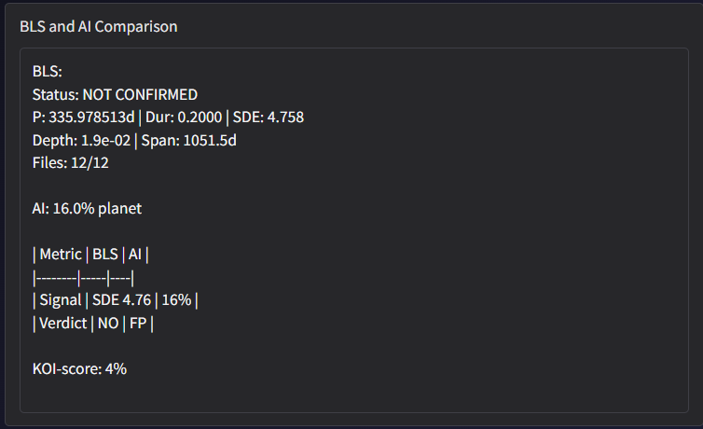
(Photo 7. BLS and Comparison)
There is another field for the graph (Lightcurve, Periodogram, Phase Folded). Graphs help users to understand data analysis more easily. Moreover, the chart allows novices in this field to draw conclusions on schedule.
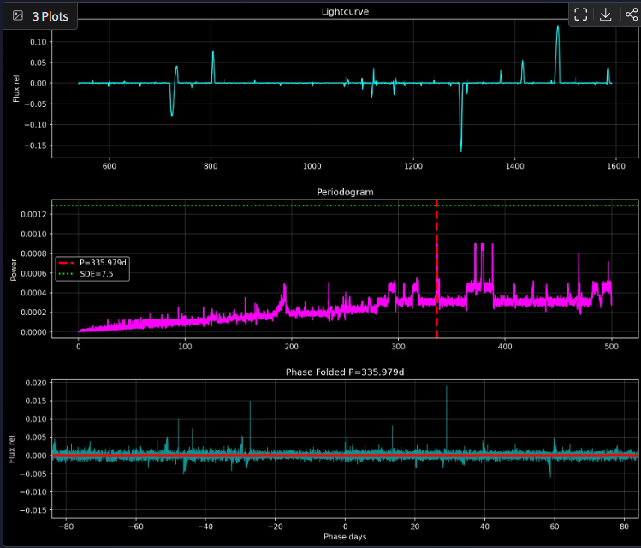
(Photo 8. Graphs)
For example, kplr012400665 has a negative result after it is booted, meaning that the candidate is not an exoplanet. The result can be checked on the database of the archive of Kepler. This result matches and it shows the correctness of the pipeline and AI.

2.4. Results and Discussion
The pipeline was tested on light curve data obtained from the Kepler missions. The preprocessing and detrending reduced noise and stellar variability, resulting in cleaner light curves suitable for analysis. This improved the visibility of possible transit features and the stability of next detection results.
BLS algorithm helped to identify periodic transit-like signals in multiple test datasets. The pipeline successfully found signals with known transit characteristics, such as regular periodicity, brief flux decreases, and box-shaped transit profiles. Phase-folded light curves provided clear visual confirmation of the detected events and facilitated qualitative assessment of candidate reliability.
Statistical metrics, such as signal detection efficiency (SDE) and transit depth, allowed for an initial evaluation of detected candidates. In some cases, low signal-to-noise events were identified that might be overlooked by rigid, large-scale automated pipelines, highlighting the advantage of adjustable parameters and user-guided exploration.
The results demonstrate that the proposed pipeline achieves reliable detection performance while maintaining full transparency of the analysis process. Compared to professional survey pipelines, the system is less optimized for large-scale processing but offers greater flexibility and interpretability. This trade-off makes the pipeline particularly well suited for educational use, exploratory research, and preliminary candidate validation.
Overall, the findings confirm that a transparent and modular approach can effectively bridge the gap between open astronomical data and practical, user-driven analysis without compromising scientific validity.

3. Conclusion

Key Results of the Work:
In this work, we developed an independent and transparent pipeline for detecting exoplanet transit signals and tested it using photometric data from the Kepler mission. The pipeline successfully performs all key stages of analysis, including data preprocessing, detrending of light curves, transit search using the Box Least Squares (BLS) algorithm, and visualization of the results.
The study confirmed that classical signal-processing methods remain effective for identifying transit-like periodic signals when applied with proper data cleaning and normalization. Several light curves were analyzed, and potential exoplanet candidates were detected based on statistically significant periodic decreases in stellar brightness. The results demonstrate that meaningful scientific analysis can be achieved without relying on large proprietary pipelines or complex machine-learning models.
The project shows a high degree of independence, as all methods were implemented using open-source tools and publicly available data, with full control over each processing stage.

Conclusions and Recommendations for Using the Results:
The developed pipeline can be effectively used for educational purposes, student research projects, and preliminary screening of exoplanet candidates. It is particularly suitable for learning astrophysical data analysis, understanding transit detection principles, and independently verifying results obtained from large survey missions.
For further use, it is recommended to apply additional validation steps, such as false-positive probability analysis or comparison with existing catalogs. Future improvements may include support for TESS data, automated candidate classification, and integration with machine-learning-based validation methods.
Overall, the results confirm that the proposed approach is practical, scalable, and valuable for independent and educational exoplanet research.

4. References
1. https://exoplanetarchive.ipac.caltech.edu/docs/KeplerMission.html
2. https://exoplanetarchive.ipac.caltech.edu/images/Kepler_Data_Products_Diagram.pdf
3. Abid, A., et al. Gradio: Quickstart. San Francisco: Gradio Inc., 2023. n.p
https://www.gradio.app/guides/quickstart
4. Kepler Mission Team. Kepler Archive Manual. Document KDMC-10008-006. Space Telescope Science Institute, 2016. 120 p.
https://archive.stsci.edu/kepler/manuals/archive_manual.pdf
5. https://exoplanetarchive.ipac.caltech.edu/cgi-bin/TblView/nph-tblView?app=ExoTbls&config=q1_q17_dr25_koi

